**Spring Core and Maven**

**Exercise 4: Creating and Configuring a Maven Project**

**Code :**

**pom.xml :**

**<project xmlns="http://maven.apache.org/POM/4.0.0"**

**xmlns:xsi="http://www.w3.org/2001/XMLSchema-instance"**

**xsi:schemaLocation="http://maven.apache.org/POM/4.0.0**

**http://maven.apache.org/xsd/maven-4.0.0.xsd">**

**<modelVersion>4.0.0</modelVersion>**

**<groupId>com.library</groupId>**

**<artifactId>LibraryManagement</artifactId>**

**<version>1.0-SNAPSHOT</version>**

**<properties>**

**<maven.compiler.source>1.8</maven.compiler.source>**

**<maven.compiler.target>1.8</maven.compiler.target>**

**</properties>**

**<dependencies>**

**<!-- Spring Context -->**

**<dependency>**

**<groupId>org.springframework</groupId>**

**<artifactId>spring-context</artifactId>**

**<version>5.3.34</version>**

**</dependency>**

**<!-- Spring AOP -->**

**<dependency>**

**<groupId>org.springframework</groupId>**

**<artifactId>spring-aop</artifactId>**

**<version>5.3.34</version>**

**</dependency>**

**<!-- Spring Web MVC -->**

**<dependency>**

**<groupId>org.springframework</groupId>**

**<artifactId>spring-webmvc</artifactId>**

**<version>5.3.34</version>**

**</dependency>**

**</dependencies>**

**<build>**

**<plugins>**

**<!-- Maven Compiler Plugin -->**

**<plugin>**

**<groupId>org.apache.maven.plugins</groupId>**

**<artifactId>maven-compiler-plugin</artifactId>**

**<version>3.11.0</version>**

**<configuration>**

**<source>1.8</source>**

**<target>1.8</target>**

**</configuration>**

**</plugin>**

**</plugins>**

**</build>**

**</project>**

**Screenshots :**

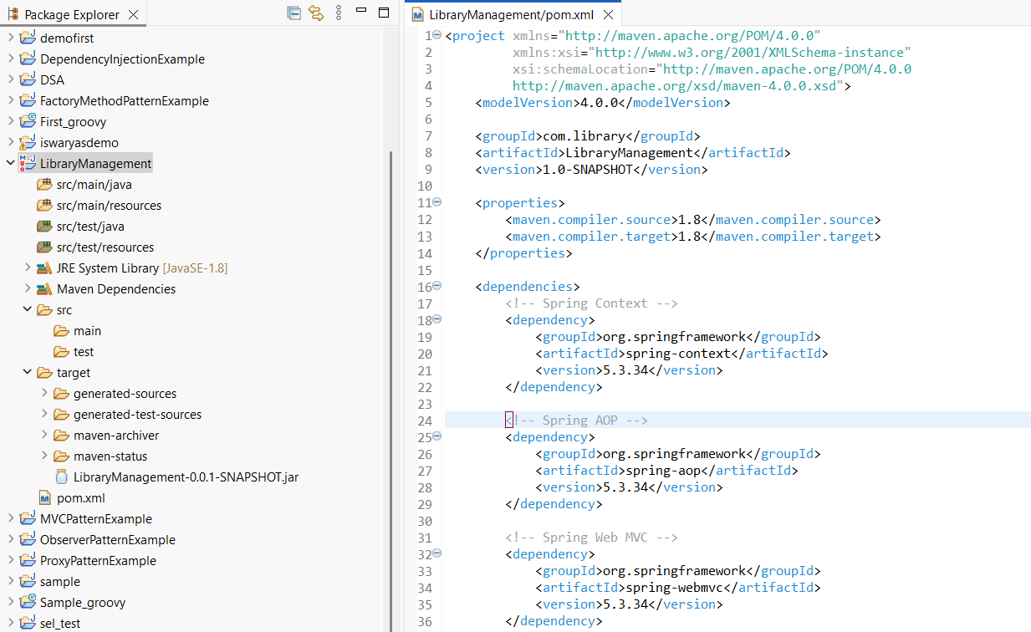

**Exercise 1: Configuring a Basic Spring Application &**

**Exercise 2: Implementing Dependency Injection**

**Project Structure :**

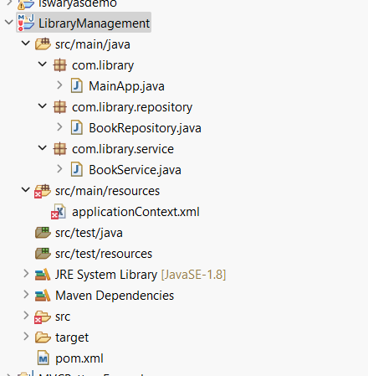

**Code :**

**applicationContext.xml**

**<?xml version=*"1.0"* encoding=*"UTF-8"*?>**

**<beans xmlns=*"http://www.springframework.org/schema/beans"***

**xmlns:xsi=*"http://www.w3.org/2001/XMLSchema-instance"***

**xsi:schemaLocation=*"***

***http://www.springframework.org/schema/beans***

***http://www.springframework.org/schema/beans/spring-beans.xsd"*>**

**<bean id=*"bookRepository"* class=*"com.library.repository.BookRepository"*/>**

**<bean id=*"bookService"* class=*"com.library.service.BookService"*>**

**<property name=*"bookRepository"* ref=*"bookRepository"*/>**

**</bean>**

**</beans>**

**BookRepository.java**

**package com.library.repository;**

**public class BookRepository {**

**public void saveBook() {**

**System.*out*.println("Book saved to the repository.");**

**}**

**}**

**BookService.java**

**package com.library.service;**

**import com.library.repository.BookRepository;**

**public class BookService {**

**private BookRepository bookRepository;**

**// Setter for DI**

**public void setBookRepository(BookRepository bookRepository) {**

**this.bookRepository = bookRepository;**

**}**

**public void addBook() {**

**bookRepository.saveBook();**

**System.*out*.println("BookService: addBook() called.");**

**}**

**}**

**MainApp.java:**

**package com.library;**

**import com.library.service.BookService;**

**import org.springframework.context.ApplicationContext;**

**import org.springframework.context.support.ClassPathXmlApplicationContext;**

**public class MainApp {**

**public static void main(String[] args) {**

**ApplicationContext context = new ClassPathXmlApplicationContext("applicationContext.xml");**

**BookService service = (BookService) context.getBean("bookService");**

**service.addBook();**

**}**

**}**

**Output:**

